Silicone Belt
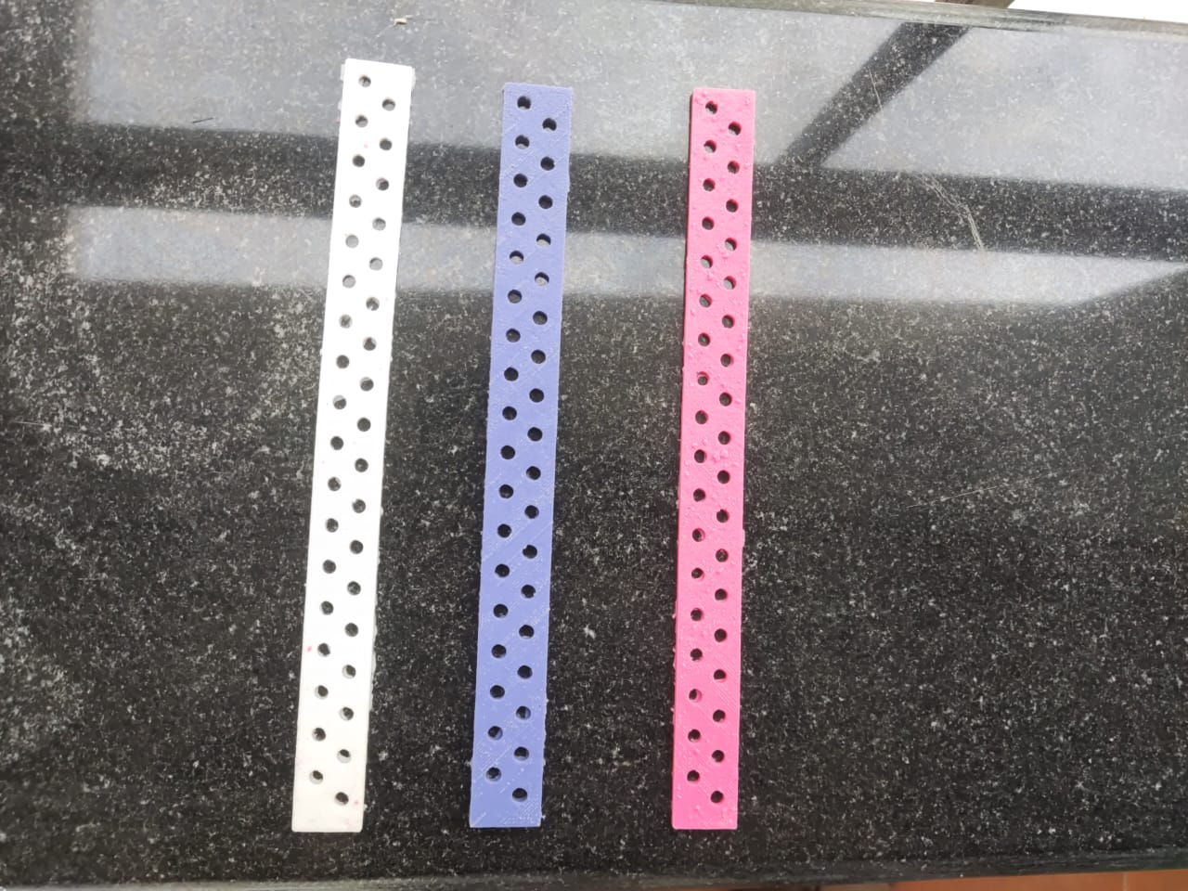
The silicone belt developed by STUDYLITCS LABS PRIVATE LIMITED for their medical device is indispensable due to its combination of comfort, durability, and functionality. Designed to enhance patient experience, the silicone material offers exceptional softness and flexibility, ensuring prolonged wear without discomfort. Its hypoallergenic nature minimizes the risk of allergic reactions, crucial in medical settings. The belt’s robustness allows for repeated use and easy cleaning, maintaining hygiene standards effortlessly. With a non-slip surface for secure positioning and water-resistant properties for reliability in diverse conditions, the silicone belt not only supports the device’s effectiveness but also prioritizes patient comfort and safety, marking it as an essential component of STUDYLITCS LABS’ innovative medical solutions.
A medical belt designed with silicone rubber offers unparalleled benefits for both patients and healthcare providers. Its hypoallergenic properties ensure compatibility with sensitive skin, reducing the risk of irritation or allergic reactions. The material's durability and flexibility provide long-lasting support and comfort, adapting seamlessly to body contours without compromising efficacy. Silicone rubber's water resistance and non-slip surface enhance usability in diverse medical environments, ensuring the belt remains securely in place during wear. Furthermore, its thermal stability and ease of sterilization facilitate maintenance and hygiene protocols, crucial in healthcare settings. Whether used for post-operative support, compression therapy, or daily medical care, a silicone rubber medical belt combines reliability, comfort, and safety, making it an indispensable tool for patient care and recovery.
The medical belt designed with silicone rubber can be of significant importance due to several key characteristics and benefits it offers:
- Hypoallergenic Properties: Silicone rubber is known for being hypoallergenic, making it suitable for individuals with sensitive skin or allergies to other materials. This reduces the risk of skin irritation or allergic reactions when wearing the belt for extended periods.
- Durability and Longevity: Silicone rubber is highly durable and resistant to wear and tear. Medical belts made from silicone can withstand frequent use and maintain their integrity over time, ensuring reliable support and functionality.
- Comfort and Flexibility: Silicone rubber is soft and flexible, providing comfort to the wearer. Medical belts designed with silicone conform to body contours without causing discomfort, which is particularly important for patients who need to wear the belt continuously.
- Water Resistance: Silicone rubber is inherently water-resistant and can withstand moisture, which is advantageous in medical applications where exposure to bodily fluids or environmental moisture is common. This property also facilitates easier cleaning and maintenance of the belt.
- Non-Slip Surface: The surface of silicone rubber can be textured or treated to enhance grip, preventing the belt from slipping or shifting during use. This ensures the belt stays securely in place, providing consistent support or compression as needed.
- Thermal Stability: Silicone rubber maintains its properties over a wide range of temperatures, from hot to cold, without becoming brittle or deforming. This makes it suitable for use in various environmental conditions without compromising its effectiveness.
- Ease of Sterilization: Medical belts made from silicone rubber are often designed to be sterilizable using methods such as autoclaving or disinfection with chemicals. This is crucial for maintaining hygiene standards in medical settings and preventing the spread of infections.
- Customizability: Silicone rubber can be molded or shaped into various forms and sizes, allowing for the customization of medical belts to meet specific patient needs or medical requirements.
In conclusion, the medical belt designed with silicone rubber combines comfort, durability, hygiene, and functionality, making it a valuable tool in medical applications where support, flexibility, and reliability are essential.

